SIMATS ENGINEERING
ASSESSMENT TOOL 1

COURSE NAME: Database Management Systems COURSE CODE: CSA05

COURSE OUTCOME COVERED

CO3: Analyze relational databases using functional dependencies, normalization
(1NF to 5NF), and key constraints to identify redundancy and ensure data integrity.
(BL2, BL3)

Activity Tool : Experiments (High) Assessment Tool Weightage: 40%

QUESTIONS Total Marks: 50
Q.No | Question | Bloom's Level | Marks
1 | For the relation STUDENT_COURSE(SID, SName, CID, CName, Instructor, Grade), identify all functional dependencies and determine the candidate keys. | BL2 – Understand | 5
2 | Demonstrate the process of converting an unnormalized relation into 1NF with step-by-step justification and example. | BL3 – Apply | 5
3 | Given relation R(A,B,C,D,E) with FDs: A→BC, BC→D, D→E. Analyze and decompose it to 2NF eliminating partial dependencies. | BL3 – Apply | 5
4 | Apply 3NF decomposition on the relation EMPLOYEE(EmpID,  EmpName, DeptID, DeptName, ManagerID) with transitive dependencies. | BL3 – Apply | 5
5 | Verify whether R(A,B,C,D) with FDs: AB→C, C→D, D→A is in BCNF. If not, decompose it into BCNF. | BL3 – Apply | 5
6 | Experimentally verify lossless-join decomposition for a given relation using the tabular (Chase) algorithm. | BL3 – Apply | 5
7 | Identify the multi-valued dependencies in TEACHER(TID, Subject, Hobby) and decompose it into 4NF. | BL3 – Apply | 5

8 | Demonstrate how join dependencies lead to redundancy. Decompose a given relation to 5NF (Project-Join Normal Form). | BL3 – Apply | 5
9 | Given a poorly designed database schema for a college, identify all anomalies (insertion, deletion, update) and normalize it to 3NF. | BL2 – Understand | 5
10 | Compute the closure of attribute sets for the given FDs and determine all candidate keys for the relation. | BL3 – Apply | 5
Code of Conduct:

I M PRASANNA VENKATESH certify that this submission is my original work and that I have adhered to the guidelines specified for this assessment. I understand that any violation of academic integrity rules will result in disciplinary action.

Signature of the student: M PRASANNA VENKATESH

RUBRICS FOR CALCULATION:

Criteria | Weightag e | Level 4 – Exemplary | Level 3 – Proficient | Level 2 – Developing | Level 1 – Beginning
Understandin g of Concepts | 25 | Demonstrates thorough understanding and effectively integrates multiple concepts/technologi  es | Good understandin g with proper integration of most concepts | Basic understandin g; limited or partial integration | Poor understandin g; unable to integrate concepts
Experimental Design | 30 | Well-planned, systematic implementation with optimal solution | Correct implementati on with minor issues | Basic implementati on with errors or  inefficiencies | Incorrect or incomplete implementati on
Use of Tools | 20 | Effective and advanced use of tools/technologies with proper  configuration | Appropriate use of tools with correct execution | Limited or inconsistent use of tools | Incorrect or minimal use of tools
Analysis of Results | 15 | Insightful analysis with accurate interpretation and validation of results | Good analysis with reasonable  interpretation | Basic analysis with limited  insights | Poor or incorrect analysis of results
Documentati on | 10 | Clear, wellstructured documentation with diagrams, code, | Organized documentatio n with necessary | Basic documentatio n with missing | Poor or incomplete documentatio n
 |  | and results | details | details

1A:
For the relation:
STUDENT_COURSE(SID, SName, CID, CName, Instructor, Grade)
Assume:
- Each SID identifies one student.
- Each CID identifies one course.
- A student can enroll in many courses.
- A course can have many students.
- A student's Grade is specific to a particular student-course combination.
Functional Dependencies
The main functional dependencies are:
- SID → SName
A student ID determines the student's name.
- CID → CName
A course ID determines the course name.
- CID → Instructor
A course ID determines its instructor.
- (SID, CID) → Grade
The combination of student ID and course ID determines the grade obtained.
Therefore, the complete set can be written as:
F = { SID → SName, CID → CName, CID → Instructor, (SID, CID) → Grade } Candidate Key
Consider (SID, CID):
  - SID determines SName.
  - CID determines CName and Instructor.
  - SID + CID determines Grade.
So:
(SID, CID)+ = {SID, SName, CID, CName, Instructor, Grade}
Hence, (SID, CID) determines all attributes.
Neither SID nor CID alone can determine all attributes, so the candidate key is:
Candidate Key: (SID, CID)

Functional Dependency | Meaning
SID → SName | Student ID determines Student Name
CID → CName | Course ID determines Course Name
CID → Instructor | Course ID determines Instructor
SID, CID → Grade | Student-Course combination determines Grade
Final Answer:
Functional Dependencies: SID → SName, CID → CName, CID → Instructor, (SID, CID) → Grade
Candidate Key: (SID, CID)
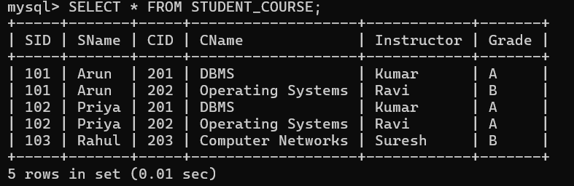

2A:
Demonstrate the Process of Converting an Unnormalized Relation into 1NF
Consider the following unnormalized relation:
STUDENT(SID, SName, Courses) Step 1: Unnormalized Form (UNF)
In the unnormalized relation, a student can have multiple courses in a single field.

SID | SName | Courses
101 | Arun | DBMS, OS
102 | Priya | DBMS, CN
103 | Rahul | OS
Here, the Courses attribute contains multiple values. Therefore, it is not in 1NF. Step 2: Identify the Problem
The relation violates First Normal Form (1NF) because:
  - Courses contains multiple values.

  - Each field should contain only one atomic value.
  - Repeating groups are present.
Step 3: Convert into 1NF
Separate each course into an individual row.

SID | SName | Course
101 | Arun | DBMS
101 | Arun | OS
102 | Priya | DBMS
102 | Priya | CN
103 | Rahul | OS
Now, every attribute contains a single atomic value. Step 4: Determine the Key
A student can take multiple courses, so SID alone cannot uniquely identify a row. The combination:
(SID, Course)
uniquely identifies each record. Therefore:
Candidate Key = (SID, Course) Step 5: Justification for 1NF
The resulting relation is in 1NF because:
- All attributes contain atomic values.
- There are no repeating groups.
- Each row represents a single student-course combination.
- The combination (SID, Course) uniquely identifies each row.
Final 1NF Relation STUDENT_CO
URSE(SID, SName, Course) Candidate Key: (SID, Course)
Thus, the unnormalized relation is converted into 1NF by eliminating multi-valued attributes and ensuring that every field contains a single atomic value.

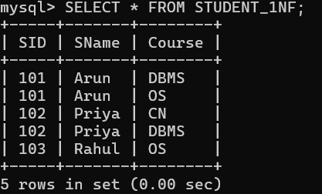

3A:

Given Relation R(A, B, C, D, E)
Functional Dependencies:
- A → BC
- BC → D
- D → E

Step 1: Find the Candidate Key
Calculate the closure of A:
A⁺ = {A}
Using A → BC:
A⁺ = {A, B, C}
Using BC → D:
A⁺ = {A, B, C, D}
Using D → E:
A⁺ = {A, B, C, D, E}
Therefore:
Candidate Key = A

Step 2: Check for Partial Dependencies
A relation is in 2NF when it is already in 1NF and there are no partial dependencies of non-key attributes on a part of a composite candidate key.
Here, the candidate key is A, which consists of only one attribute. Therefore, partial dependency is not possible.

So, R is already in 2NF.

Step 3: Dependency Analysis
The dependencies are:

FD Type
A → B, C Full dependency on key A
BC → D Dependency between non-key attributes D → E Dependency between non-key attributes
There is no partial dependency, because the key contains only A.
Final Answer Candidate Key: A 2NF Relation:
R(A, B, C, D, E)
No decomposition is required to achieve 2NF.
Note: The relation has a transitive dependency (A → D → E), so it is not in 3NF. A further decomposition would be needed for 3NF.
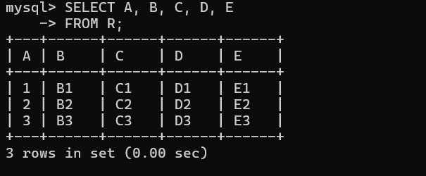

4A:
-- 1. Create Original EMPLOYEE Table

CREATE TABLE EMPLOYEE ( EmpID INT PRIMARY KEY, EmpName VARCHAR(50), DeptID INT,
DeptName VARCHAR(50), ManagerID INT
);

-- 2. Insert Data

INSERT INTO EMPLOYEE VALUES
(101, 'Arun', 10, 'Computer Science', 201),
(102, 'Priya', 10, 'Computer Science', 201),
(103, 'Rahul', 20, 'Mechanical', 202),
(104, 'Sahil', 20, 'Mechanical', 202);

-- 3. Display Original Table

SELECT * FROM EMPLOYEE;

-- 4. Create DEPARTMENT Table for 3NF

CREATE TABLE DEPARTMENT ( DeptID INT PRIMARY KEY, DeptName VARCHAR(50), ManagerID INT

);

-- 5. Insert Department Data

INSERT INTO DEPARTMENT VALUES
(10, 'Computer Science', 201),
(20, 'Mechanical', 202);

-- 6. Create EMPLOYEE_3NF Table

CREATE TABLE EMPLOYEE_3NF ( EmpID INT PRIMARY KEY, EmpName VARCHAR(50),
DeptID INT,
FOREIGN KEY (DeptID) REFERENCES DEPARTMENT(DeptID)
);

-- 7. Insert Employee Data

INSERT INTO EMPLOYEE_3NF VALUES (101, 'Arun', 10),
(102, 'Priya', 10),
(103, 'Rahul', 20),
(104, 'Sahil', 20);

-- 8. Display EMPLOYEE_3NF

SELECT * FROM EMPLOYEE_3NF;

-- 9. Display Department Details

SELECT * FROM DEPARTMENT;

-- 10. Join Both Tables

SELECT e.EmpID, e.EmpName, d.DeptID, d.DeptName, d.ManagerID FROM EMPLOYEE_3NF e
JOIN DEPARTMENT d
ON e.DeptID = d.DeptID;
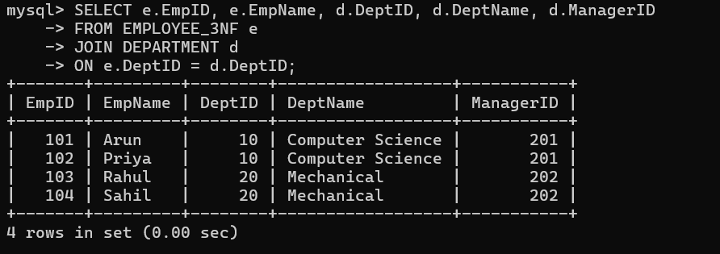

5A:

BCNF Verification and Decomposition
Given relation:
R(A, B, C, D)
Functional Dependencies:
- AB → C
- C → D
- D → A
Step 1: Find Candidate Keys AB⁺:
AB → C → D → A Therefore:
AB⁺ = {A, B, C, D}

So AB is a candidate key.
BC⁺:
C → D → A Therefore:
BC⁺ = {A, B, C, D}
So BC is a candidate key.
BD⁺:
D → A, and AB → C Therefore:
BD⁺ = {A, B, C, D}
So BD is also a candidate key. Candidate keys are:
AB, BC, BD

Step 2: Check BCNF
For BCNF, for every non-trivial FD X → Y, X must be a superkey.
- AB → C → AB is a candidate key ✅
- C → D → C is not a superkey ❌
- D → A → D is not a superkey ❌
Therefore:

R is NOT in BCNF.
Step 3: BCNF Decomposition
Using the violating dependency C → D, decompose:
R₁(C, D)
R₂(A, B, C)
For R₁(C,D):
C → D, and C is a key of R₁. Therefore, R₁ is in BCNF.
For R₂(A,B,C):
AB → C, and AB is a key of R₂. Therefore, R₂ is in BCNF.

Final Answer

BCNF decomposition:
R₁(C, D)
R₂(A, B, C)
Both relations satisfy BCNF.
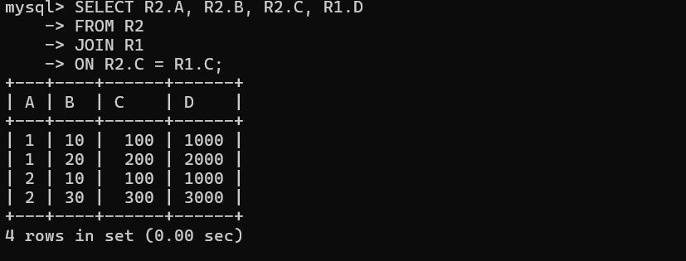

6A:

Lossless-Join Decomposition Using Chase Algorithm
Consider the relation:
R(A, B, C)
Functional dependency:
A → B
Decompose R into:
- R₁(A, B)
- R₂(A, C)

Step 1: Initial Chase Table

Row | A | B | C
R₁ | a | b | c₁
R₂ | a | b₂ | c
Here, common attribute A has the same value a.
Step 2: Apply FD A → B
Since both rows have the same value for A, the FD A → B forces their B values to become equal.

Row | A | B | C
R₁ | a | b | c₁
R₂ | a | b | c
Now the first row contains:
a, b, c₁
and the second row contains:

a, b, c
Step 3: Check the Chase Result
A row contains the distinguished symbols for all attributes: (a, b, c)
Therefore, the decomposition is lossless-join. Conclusion
R(A,B,C) → R₁(A,B), R₂(A,C) is a lossless-join decomposition because the Chase algorithm produces a row containing all distinguished values.
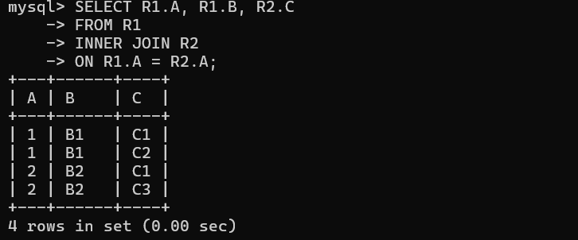

7A:

4NF Decomposition of TEACHER
Given relation:

TEACHER(TID, Subject, Hobby)
Assume a teacher can independently have multiple subjects and multiple hobbies. Step 1: Identify Multi-Valued Dependencies
The multi-valued dependencies are:
- TID →→ Subject
- TID →→ Hobby
This means the subjects and hobbies of a teacher are independent of each other.

Step 2: Problem in the Original Relation
For example:

TID | Subject | Hobby
1 | DBMS | Cricket
1 | DBMS | Music
1 | OS | Cricket
1 | OS | Music
The combinations create unnecessary redundancy.

Step 3: Decompose into 4NF
Using the MVD TID →→ Subject, decompose the relation into:
TEACHER_SUBJECT(TID, Subject)
and
TEACHER_HOBBY(TID, Hobby)
Step 4: Final 4NF Relations TEACHER_SUBJECT
TID | Subject
1 | DBMS
1 | OS

TEACHER_HOBBY

TID | Hobby
1 | Cricket
1 | Music

Conclusion
The original relation violates 4NF because of the non-trivial multivalued dependencies:
TID →→ Subject TID →→ Hobby
The 4NF decomposition is:
TEACHER_SUBJECT(TID, Subject) TEACHER_HOBBY(TID, Hobby)
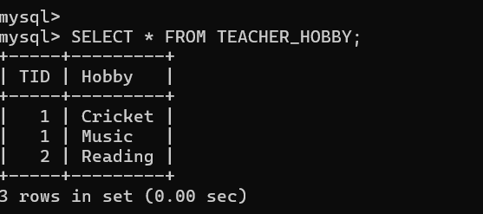

8A:

5NF Decomposition Using Join Dependencies
Consider the relation:
SUPPLIER_PART_PROJECT(Supplier, Part, Project)
Suppose a supplier supplies a particular part for a particular project. Step 1: Original Relation
Supplier | Part | Project
S1 | P1 | J1
S1 | P1 | J2
S1 | P2 | J1
S2 | P1 | J1
If the relationships between Supplier, Part, and Project are independent, storing all three together can create redundancy.

Step 2: Join Dependency
The relation can be represented using three smaller relations:

SP(Supplier, Part)
- SJ(Supplier, Project)
- PJ(Part, Project) The join dependency is: R = SP ⋈ SJ ⋈ PJ

Step 3: Decomposition SP(Supplier, Part)
Supplier | Part
S1 | P1
S1 | P2
S2 | P1

SJ(Supplier, Project)

Supplier | Project
S1 | J1
S1 | J2

S2 | J1

PJ(Part, Project)

Part | Project
P1 | J1
P1 | J2
P2 | J1

Step 4: Why Redundancy Occurs
In the original three-attribute relation, information about the same supplier-part or supplier-project relationship may be repeated across multiple rows.
For example, if S1 supplies P1 for several projects, S1-P1 is repeated for each project. The decomposition stores each independent relationship only once.

Step 5: 5NF Relations
The final decomposition is:

SP(Supplier, Part) SJ(Supplier, Project) PJ(Part, Project)
These relations are in 5NF (Project-Join Normal Form) when every non-trivial join dependency is implied by the candidate keys.

Conclusion
Join dependencies can cause redundancy when a relation contains several independent many-to-many relationships. Decomposing the relation into smaller relations removes this redundancy while allowing the original relation to be reconstructed through joins.
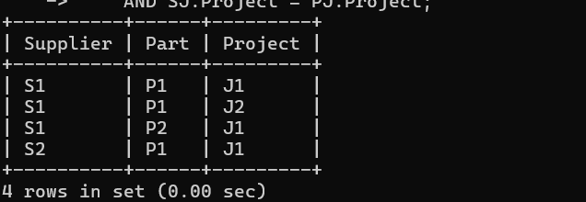

9A:

College Database: Anomalies and 3NF Normalization
Consider the poorly designed relation:

COLLEGE(StudentID, StudentName, DeptID, DeptName, CourseID, CourseName, Instructor)
- Functional Dependencies
Assume:
  - StudentID → StudentName, DeptID
  - DeptID → DeptName
  - CourseID → CourseName, Instructor There are transitive dependencies:
StudentID → DeptID → DeptName

Anomalies Insertion Anomaly
  - A new department cannot be stored unless at least one student is enrolled.
  - A new course cannot be added unless a student is registered for it.

Deletion Anomaly
  - If the last student in a department is deleted, the department information may also be lost.
  - If the last student taking a course is deleted, course information may be lost.

Update Anomaly
  - If a department name changes, it must be updated in multiple student records.
  - Missing one update can create inconsistent data.

Normalize to 3NF
Decompose the original relation into: STUDENT(StudentID, StudentName, DeptID) DEPARTMENT(DeptID, DeptName) COURSE(CourseID, CourseName, Instructor) If students can enroll in multiple courses, create: ENROLLMENT(StudentID, CourseID)

Final 3NF Schema

STUDENT(StudentID, StudentName, DeptID) DEPARTMENT(DeptID, DeptName) COURSE(CourseID, CourseName, Instructor) ENROLLMENT(StudentID, CourseID) Conclusion
The original college schema contains insertion, deletion, and update anomalies due to redundancy and transitive dependencies. Decomposing it into STUDENT, DEPARTMENT, COURSE, and ENROLLMENT removes these anomalies and produces a 3NF database design.
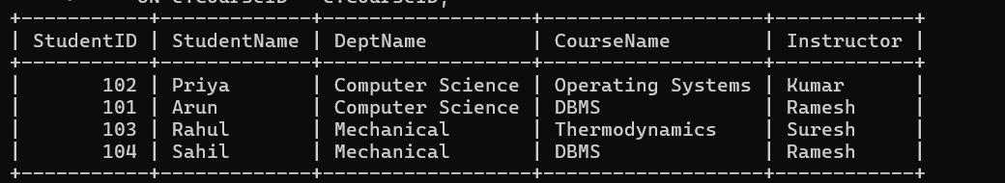

10A:
Compute Attribute Closures and Candidate Keys Relation: R(A, B, C, D, E)

Functional Dependencies (FDs):
  - A → BC
  - B → D
  - CD → E
- Compute A⁺
Start with:
A⁺ = {A}
Using A → BC: A⁺ = {A, B, C}
Using B → D:
A⁺ = {A, B, C, D}
Using CD → E:
A⁺ = {A, B, C, D, E}
Therefore:

A⁺ = {A, B, C, D, E}
Since A⁺ contains all attributes, A is a candidate key.

- Compute B⁺
Start:
B⁺ = {B}
Using B → D:
B⁺ = {B, D}
No other FD can be applied. Therefore:
B⁺ = {B, D}
Not a key.

- Compute C⁺ C⁺ = {C}
No FD can be applied.
Therefore:
C⁺ = {C}
Not a key.

- Compute D⁺ D⁺ = {D}
No FD can be applied.
Therefore:
D⁺ = {D}
Not a key.

- Compute E⁺ E⁺ = {E}
No FD can be applied.

Therefore:
E⁺ = {E}
Not a key.

Check possible composite keys
Since A alone is already a key, any set containing A is not minimal.
Sets without A cannot determine A because A never appears on the right-hand side of any FD. Therefore, no set without A can be a candidate key.

Final Result

Attribute Set | Closure | Candidate Key?
A | {A, B, C, D, E} | Yes
B | {B, D} | No
C | {C} | No
D | {D} | No
E | {E} | No

Answer
The only candidate key is {A}. Prime attribute: A
Non-prime attributes: B, C, D, E
